# How to Use Code Reviews on Visual Studio

Select Team Explorer tab and select My Work. You will see Code Reviews at bottom of screen (my need to expand Code Reviews first)

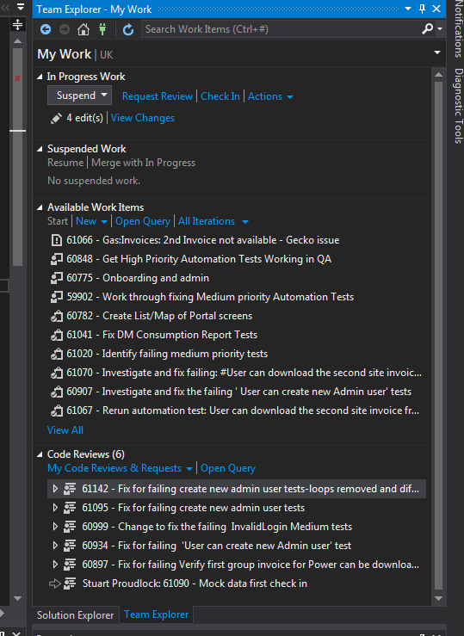

Double click on the Code Review you want to see/respond to the reviews for

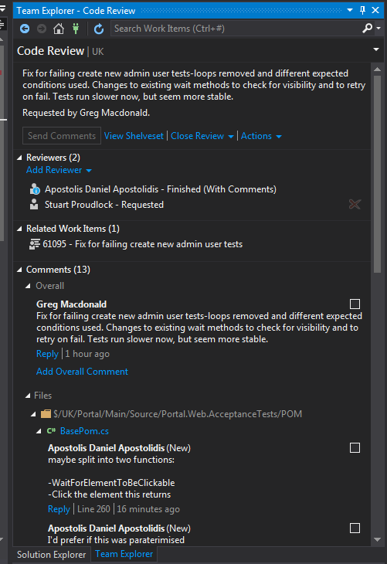

Click on Reply if you just want respond with a comment of your own.

IF code change required, double click on the review comment and it will take you to the relevant code

Click on Edit local file to make changes to the code

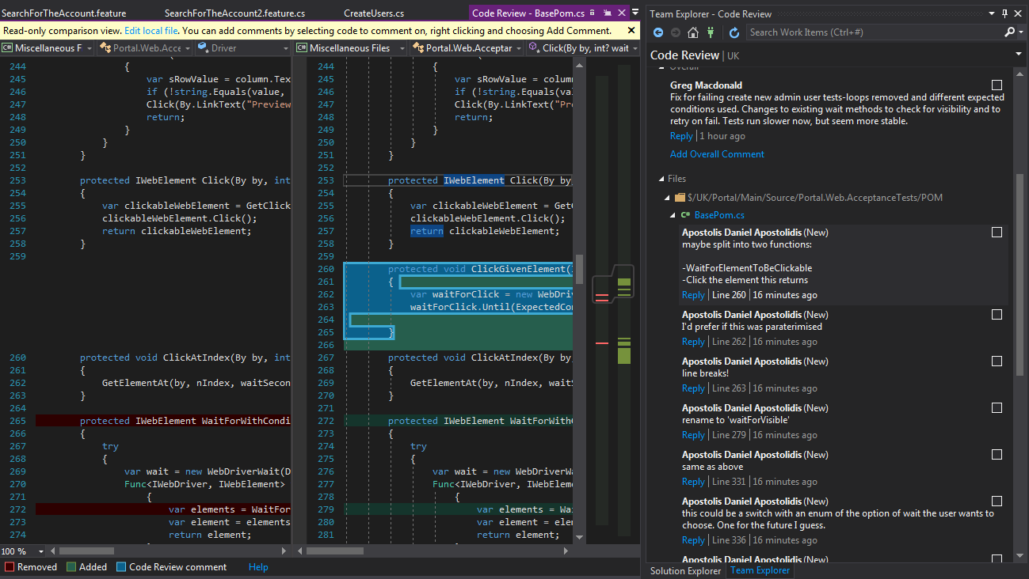

Once the comment has been responded to (either by comment or code change), click on the tick box